> > > > > > > > > > > > > > > > > > > > > > > > > > > > > > > > > > > > > > > > > > > > >
__________________________________________________________________
How To Use This Document:
The email below is a template you can use to invite new co-workers to participate in the Commuter Challenge. Feel free to copy directly, write your own or edit the template below to fit your specific workplace. Please note the red bolds and add in your team’s information where necessary.
Helpful Hint: You will need to copy and paste the Shareable Join URL that is unique to your Workplace Network. This allows participants to automatically join your team when they register for Way to Go. *Refer to screenshots on page 3 of this document*. FYI participants only need to click this link once. Then all of their trips logged during the challenge will count towards your team. To access the URL: log in to your Way to Go! Missoula account and follow these steps:
Manage tab → Management Dashboard → Your Network → Network home → Edit
(see page #3 of this document for screenshots)
_____________________________________________________________________________________

Intro Email for First Time Challenge Participants:
MAY 5 – 18
Sign up. Commute Sustainably. Log trips. Win.
Did you know that the transportation sector contributes 35% of all local greenhouse gas emissions? We at ‘Workplace Name’ are challenging ourselves to be a part of the solution by participating in Missoula In Motion’s annual Commuter Challenge! Save money, improve air quality and reduce emissions by fitting in a commute by bus, bike, foot, carpool, vanpool, or even working from home.

HEAD-TO-HEAD COMPETITION
We’re competing against workplaces of a similar size to see who can make the most sustainable commutes to work between May 5 - 18. There are tons of prizes and multiple ways to win as both as a team and an individual.
IT'S SUPER EASY
All we have to do is log our trips on Way to Go! Missoula. If we are the ONLY team in our size category to have everyone log at least ONE sustainable commute between May 5 - 18 then we WIN!!! Even if it’s just one time - one trip is all it takes. We can do it!

Join the Challenge as a member of Team Workplace Name here: (insert Shareable Join URL).
- If you already have a Way to Go account, just click the link and sign in
- If you’re new to using Way to Go, use the link to sign up for an account
Now you can start logging sustainable commutes and tracking your impact! Watch this How-to-video to see how easy it is to log trips with Way to Go! Missoula.
Thanks for your commitment to seeing commuting differently. Let me know if you have any questions, I’m here to help us win this thing!!

Your Name
Navigating to your Workplace Network:
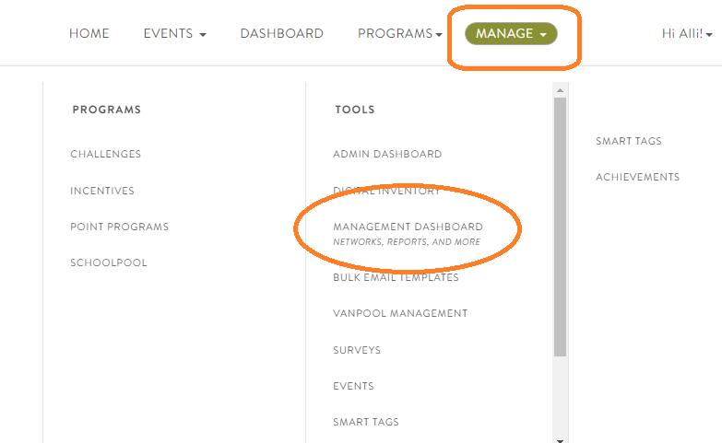
Finding your Shareable Join URL:
