Commuter Challenge Email Templates Pre Challenge + Week 1 (May 1st - May 9th)
Missoula In Motion has prepped some sample email messages that are useful in spreading the word about the Commuter Challenge in your workplace. Feel free to edit the materials to suit your purposes, style, weather etc. (please note the red bolds and edit as appropriate).

Pro Tip: Take a few minutes to schedule your emails ahead of time so you don’t forget.
_________________________________________________________
Send out date: Friday, May 1st
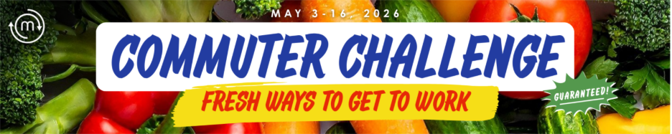
Missoula In Motion's annual Commuter Challenge is just around the corner and this year, we’re shopping our options for fresh ways to get to work! Join forces with our team at Workplace Name and stock up on sustainable ways to travel. The Challenge runs from May 3rd to May 16th and every day that you take and log a sustainable commute, you could win a $50 gift card to a local business.
Today, you might be craving a brisk bike ride, tomorrow you’re in the mood to tune-out with a book on the bus, and later in the week you carpool with a coworker or take a refreshing walk. Mix it up & sample what’s available.
Plus, there are 2 parties hosted by Missoula In Motion for us to celebrate our commuting efforts! The Kick-Off Party is May 4th at Cranky Sam’s from 4:30-6:30 and the first drink is free for Challenge participants!
The big team goal is winning our size category! If we are the ONLY team in our size category to have everyone commit to traveling by any mode other than driving alone at least ONE time between May 3-16 then we WIN that FREE PIZZA PARTY! One time, one commute. That’s it! Every other time helps boost our odds!
Other ways to win as a team include:
- Best Team Photo – let's get together on choose a day to take a picture to send to MIM!
- Best Social Media presence – post about your sustainable commutes and tag our workplace and @missoulainmotion!
- Most Into It – an ice cream party for teams that go above and beyond. Let me know if you have any fun ideas for our team.
There are also so many ways to win as an individual!
- Daily $50 raffles – chance to win one of TWO gift cards each work day. See raffle prizes for week 1 below! Try the mode of the day for better odds:
Monday: Bus Tuesday: Telework Wednesday: Carpool Thursday: Bike Friday: Walk
- 10 Day Medalist – everyone who logs a sustainable commute for all 10 work days of the challenge wins a free cone card.
So instead of hopping in your car alone to get to the office, sample all your options.
Start logging those sustainable commutes with Way to Go! and yes, working from home and carpooling are sustainable modes that are eligible during the Commuter Challenge! Let me know if you have any questions.

Signed, XXXXXX
Your Commuter Challenge Captain
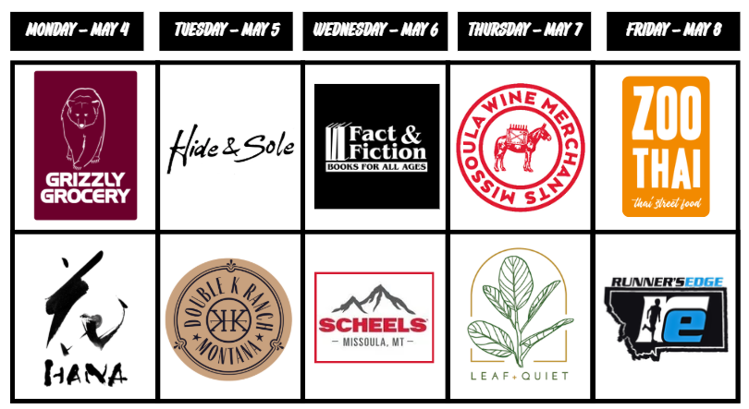
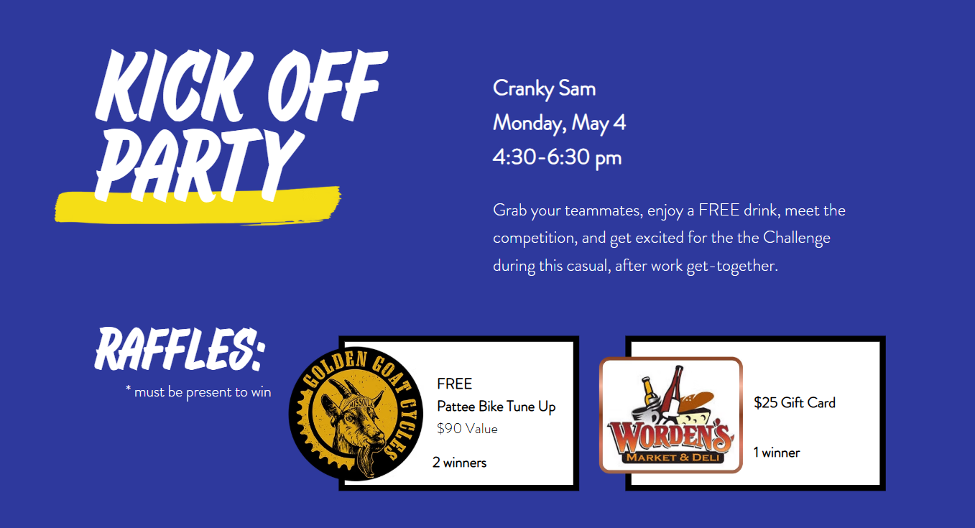

Send out date: Wednesday, May 6th

Team Workplace Name,
Week 1 is off with a bang! Remember what I said about daily raffle drawings? Log today’s sustainable commute with Way to Go before 11AM tomorrow to be entered to win a $50 gift card to Fact & Fiction or Leaf & Quiet (extra entry if you took a carpool trip). Check the raffle schedule for the rest of this week:
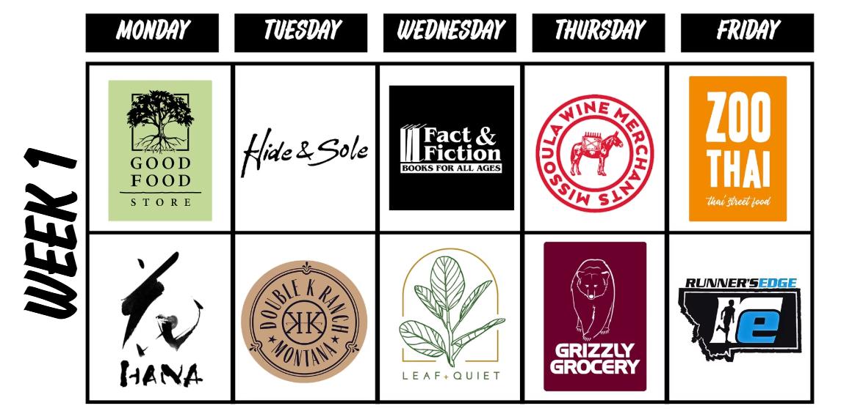
New to using Way to Go or need a refresher on how to log a trip? Check out this guide. The app is gone, but the site is now mobile-friendly for easier logging from your phone’s web browser.
Let’s take this day by day, team. We're aiming for at least ONE trip, ONE time from each and every one of us at Team Workplace Name. That’s how we become an All-Star Team!

Signed,
XXXXXX Your Commuter Captain
Send out date: Friday, May 9th
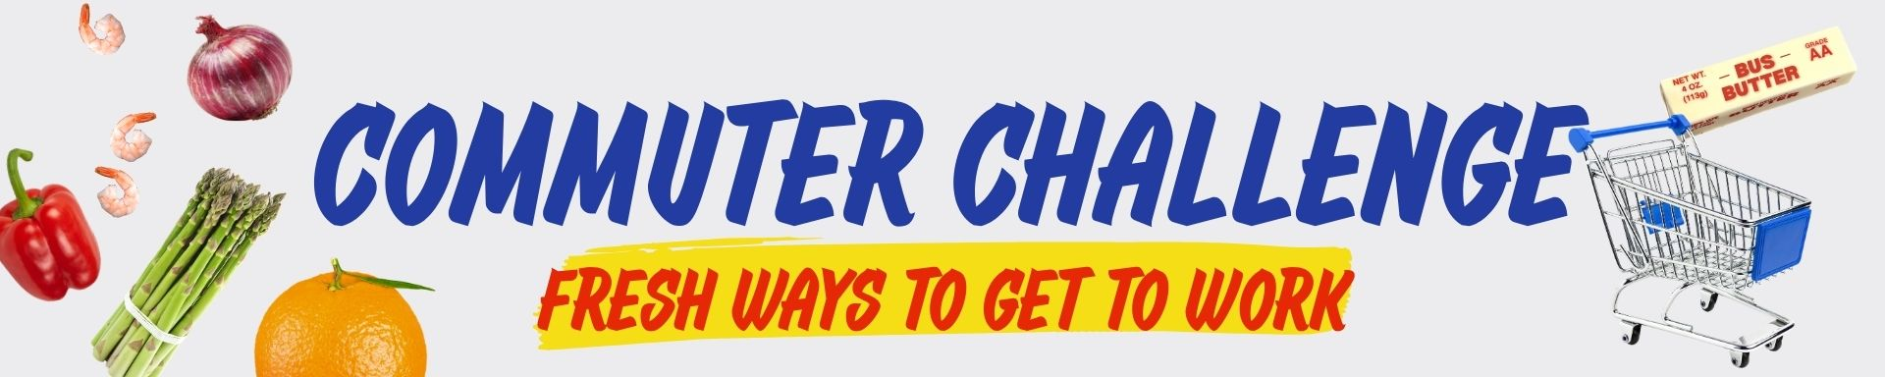
3 Cheers for everyone for a successful week one of the Commuter Challenge! Fantastic effort all around, with special kudos to Amy, Bob, & Charlie [Replace with names in your organization], who are contenders for 10 Day Medalist status and free cone card!
Hopefully you’ve felt the wind in your hair on the bike path or waved to a bus driver! Let’s keep it rolling next week, too!
Folks can keep track of our progress on the challenge leaderboards here to see how we’re stacking up against the competition:

  - Micro (3-8 employees)
  - Small (9-19)
  - Medium (20-49)
  - Large (50-100)
  - Macro (more than 100)
Noticed other key features on Way to Go! Missoula?
- Automatically earn monthly rewards when you log trips all year long– even after the Challenge!
- Guaranteed Ride Home. If you use a sustainable mode, but need to pick up your child from school during the day or get home after you missed the last bus, you can be reimbursed for the cost of your taxi, uber, lyft, etc.
- Carpool matching platform to search and connect with others to share rides with.

Remember, every day you log a sustainable trip you’re entered into a raffle for a $50 gift card. The winner for trips logged today through Sunday will be drawn on Monday at noon. And the more times we collectively choose and log a sustainable commute, the better our chances of winning that team pizza party!!
Don’t forget to log those sustainable commutes and have a great weekend!

Signed, XXXXXX
Your Commuter Captain

