Commuter Challenge Email Templates Week 2 (May 10th - May 16th)
Missoula In Motion has prepped some sample email messages that might be useful to you as you spread the word about the Commuter Challenge in your workplace. Feel free to edit the materials to suit your purposes, style, weather etc. (please note the red bolds and edit as needed).
Pro Tip: Take a few minutes to schedule your emails ahead of time so you don’t forget.
___________________________________________________________
Send out date: Monday, May 11th
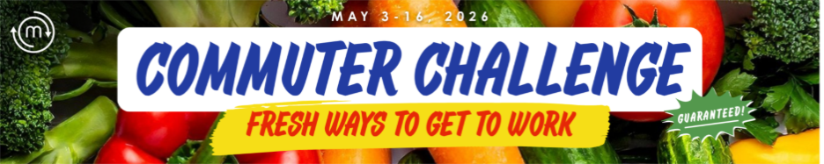
Hi Folks-
Happy Week 2 of the Commuter Challenge! Have you logged your sustainable trip yet? Logging your telework, bus, bike, carpool, or walk trip on Way to Go! Missoula brings our team one step closer to victory AND enters you into a daily raffle for one of TWO $50 gift cards! See all the prizes here.
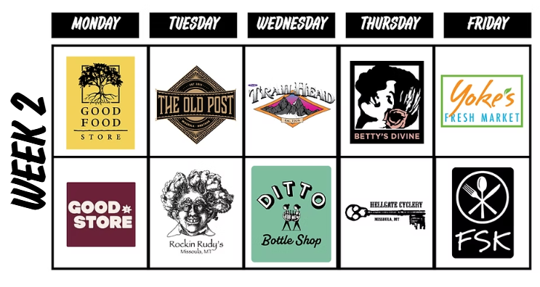
ProTips:
Is your cubical mate skeptical of the challenge? Offer to pick them up on your way into the office, so you both can log a carpool for the team! You’ll get an extra entry into the daily raffle if you carpool on Wednesday!

See how the competition is shaping up on the Challenge Leaderboards (click on our team to see your status!) You can also find leaderboards on your Way to Go! Dashboard under “Challenges”
Micro Category Leaderboard (3 - 8 employees)
Small Category Leaderboard (9 – 19 employees)
Medium Category Leaderboard (20 – 49 employees)
Large Category Leaderboard (50 – 75 employees)
Macro Category Leaderboard (100+ employees)
Signed, XXXXXX
Your Commuter Challenge Captain

Send out date: Wednesday, May 13th
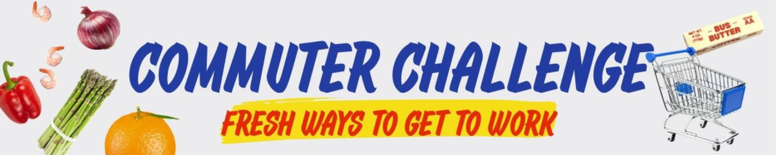
Team Workplace Name,
The Challenge is nearly over! This Saturday is the LAST day of the challenge so make sure you try a sustainable mode and log your trip as soon as possible! The official last day to log a trip for the Challenge is MONDAY, May 18th.
Juggling the kids’ drop off and a sustainable commute? Here’s an idea – drive your kids to school/daycare, then park your car there and hop on a bike or bus for the final leg of your trip to the office. Use the school’s address as destination #1 when logging your trip. Carpooling is also a great option!
Here’s another way we can win (Anyone interested in an ice cream drop off?): Let's step up our social media game! Tag @YourOrganization’s Social Media @missoulainmotion to get us in the running for Best Social Media Presence and Best Team Photo!
Nominate a Commuter of the Year! Does someone on our team go above and beyond to fit sustainable transportation into their routine? Maybe they inspire others to do the same? Fill out this short nomination form and they can win $250 in gear from the Trail Head!
Keep up the good work!

Signed, XXXXXX
Your Commuter Challenge Captain

Send out date: Friday, May 15th

TGIF! Tomorrow is the last day of the Commuter Challenge!
Can you almost taste that free ice cream for achieving the 10-Day Medalist status? Me too!
Remember, ALL sustainable commutes must be logged at waytogo.missoulainmotion.com by MONDAY, May 18th. But, you might as well go ahead and do it now!
Now that the challenge is wrapping up, you can calculate the amount of CO2 your sustainable trips diverted as well as the cash-money you saved! To find these stats, simply login here and scroll to the bottom of your Dashboard.
The prizes and rewards don’t stop now that the Challenge is ending. You can earn a reward EVERY month via Way to Go! Missoula! Each month, you can pick from 2 different reward options offered by local Missoula In Motion business partners. Did you redeem your reward for May yet? If not, visit your Way to Go Dashboard, click “Rewards, then open the “May Trip Challenge” to choose from $5 to Double K Ranch, a Big Dipper cone card, or $5 to Fact & Fiction.
Thanks to everyone for your efforts these past two weeks - I'll keep you posted on the results!
Let’s go to the Awards Party together – June 2nd/ 4:30-6:30 pm // Western Cider. Challenge Participants get their first drink free!
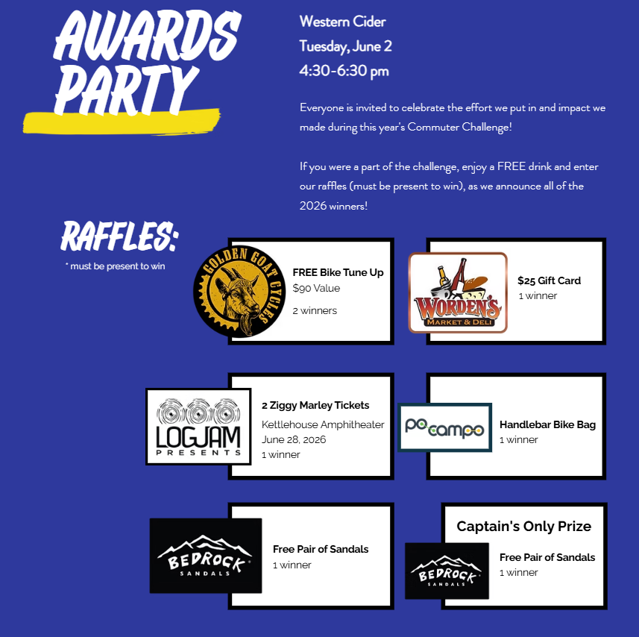
Signed, XXXXXX
Your Commuter Challenge Captain

